DATA STURCTURES

NAME:SARAVANAVELU.D REGNO:192224249

DAY-1

DATA STRUCTURES

1.Write a C program to find the given number is odd or even.

#include<stdio.h>

int main()

{

int n;

printf("enter the number");

scanf("%d",&n);

if(n%2==0)

printf("it is even no");

else

printf("it is odd no");

}

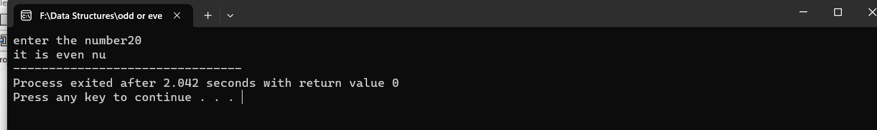

2.Write a C program to find sum of natural number using foor loop.

#include<stdio.h>

int main()

{

int i,n,sum;

printf("enert the number");

scanf("%d",&n);

for(i=1;i<=n;++i)

{

sum=sum+i;

}

printf(" %d",sum);

}

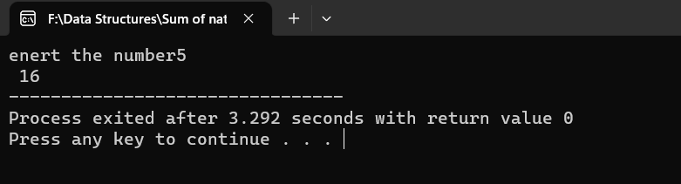

3.Write a C program to find sum of even natural number using while loop.

#include<stdio.h>

int main()

{

int i=2,n,sum=0;

printf("enter the number");

scanf("%d",&n);

while(i<=n)

{

if(i%2==0)

{

sum+=i;

}

++i;

}

printf("%d",sum);

return 0;

}

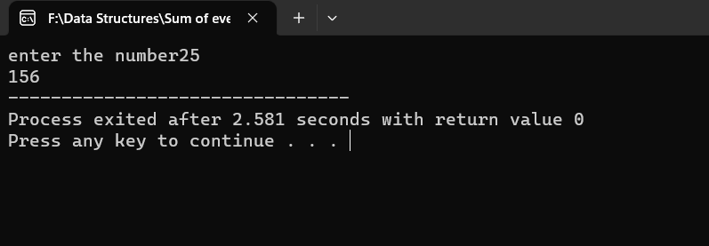

4.Write a C program to reverse the given number.

#include<stdio.h>

int main()

{

int n,rev=0,rem;

printf("enter the number");

scanf("%d",&n);

while(n!=0)

{

rem=n%10;

rev=rev*10+rem;

n=n/10;

}

printf("revers no %d",rev);

}

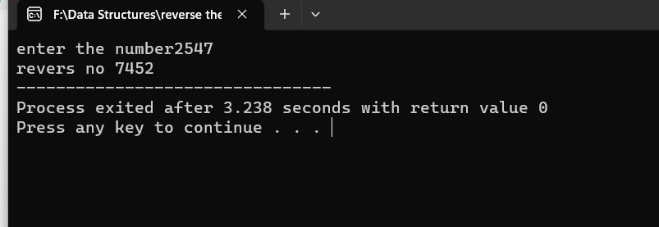

5.Write a C program to check the given number is palindrome number or not.

#include<stdio.h>

int main()

{

int orginaln,n,rem,sum=0;

printf("enter the number");

scanf("%d",&n);

orginaln=n;

while(n!=0)

{

rem=n%10;

sum=sum*10+rem;

n=n/10;

}

if(orginaln==sum)

printf("it is palindrome no");

else

printf("it is not an palindrome no ");

}

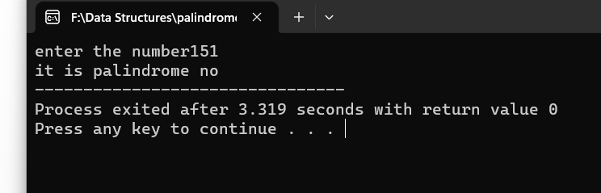

6.Write a C program to check the given number is armstrong number or not.

#include<stdio.h>

int main()

{

int temp,n,rem,sum=0;

printf("enter the number");

scanf("%d",&n);

temp=n;

while(n>0)

{

rem=n%10;

sum=sum+(rem*rem*rem);

n=n/10;

}

if(temp==sum)

printf("it is armstrong no ");

else

printf("it is not an armstrong no");

return 0;

}

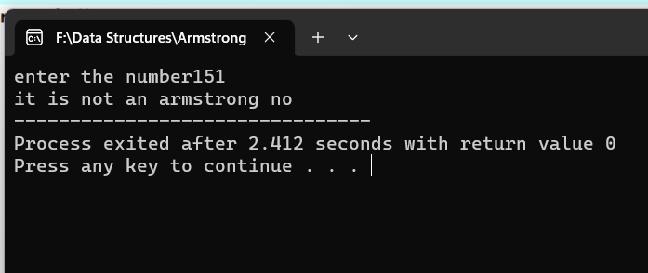

7.Write a C program to find factorial of given number with recursion.

#include<stdio.h>

#include<conio.h>

int fact(int number)

{

if(number==0 || number==1)

return 1;

else

return(number * fact(number-1));

}

int main()

{

int n,f;

printf("\n Enter the number: ");

scanf("%d",&n);

f=fact(n);

printf("\n The factorial of the number %d is %d",n,f);

}

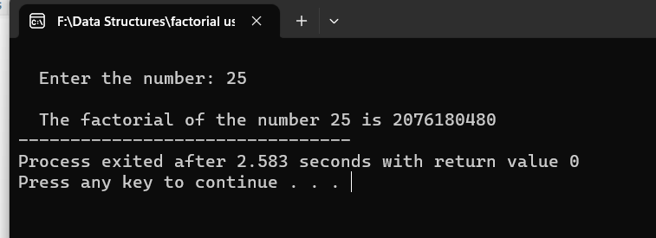

8.Write a C program to find factorial of given number without recursion.

#include<stdio.h>

int main() {

int n, i;

long factorial = 1;

printf("Enter an no ");

scanf("%d",&n);

for(i=1; i<=n; ++i) {

factorial *= i;

}

printf("Factorial of %d = %llu", n, factorial);

return 0;

}

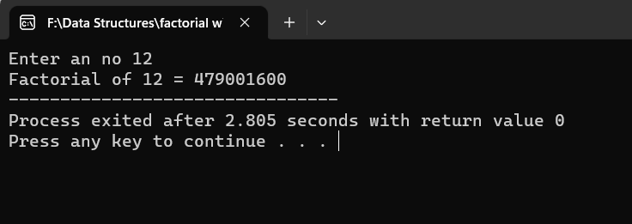

9.Write a C program to generate Fibonacci series with recursion.

#include <stdio.h>

int Fibonacci(int n)

{

static int n1= 0,n2=1,n3;

if(n > 0){

n3 = n1 + n2;

n1 = n2;

n2 = n3;

printf("%d",n3);

Fibonacci(n-1);

}

}

int main(){

int n;

printf("Enter the number of elements: ");

scanf("%d", &n);

printf("Fibonacci Series: ");

printf("%d %d",0,1);

Fibonacci(n-2);

return 0;

}

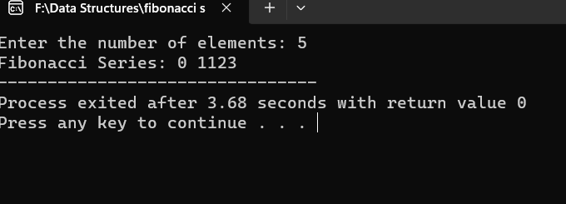

10.Write a C program to generate Fibonacci series without recursion.

#include<stdio.h>

int main()

{

int a=0,b=1,result=0,n,i;

printf("enter the number");

scanf("%d",&n);

for(i=0;i<=n;i++)

{

printf("%d",a);

result=a+b;

a=b;

b=result;

}

}

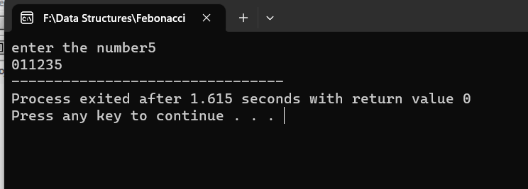

11.Write a C program to search the particular element array using Linear search.

#include <stdio.h>

int linearSearch(int array[], int size, int element) {

for(int i = 0; i < size; i++) {

if(array[i] == element)

return i;

}

return -1;

}

int main() {

int array[] = {1, 3, 5, 7, 9}, element;

int size = sizeof(array) / sizeof(array[0]);

printf("Enter the element to be searched: ");

scanf("%d", &element);

int searchResult = linearSearch(array, size, element);

if(searchResult != -1)

printf("Element found at index: %d", searchResult);

else

printf("Element not found in the array.");

return 0;

}

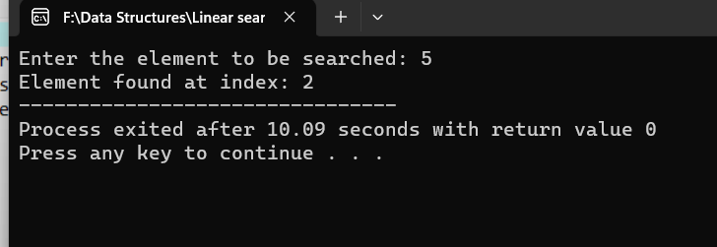

12. Write a C program to search the particular element array using Binary search.

#include <stdio.h>

int start = 0, end = size-1;

while(start <= end) {

int mid = (start + end) / 2;

if (array[mid] == element)

return mid;

if (array[mid] < element)

start = mid + 1;

else

end = mid - 1;

}

return -1;

}

int main() {

int array[] = {387,333,331,987,689}, element;

int size = sizeof(array) / sizeof(array[0]);

printf("Enter the element to be searched: ");

scanf("%d", &element);

int searchResult = binarySearch(array, size, element);

if(searchResult != -1)

printf("Element found at index: %d", searchResult);

else

printf("Element not found in the array.");

return 0;

}

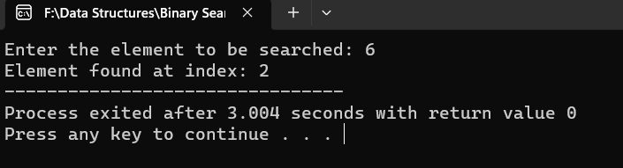

DAY-2

1. write a c program sum of elements in a array.

Program:

#include<stdio.h>

#include<string.h>

int main()

{

int a[1000],i,n,sum=0;

printf("Enter size of the array : ");

scanf("%d",&n);

printf("Enter elements in array : ");

for(i=0; i<n; i++)

{

scanf("%d",&a[i]);

}

for(i=0; i<n; i++)

{

sum+=a[i];

}

printf("sum of array is : %d",sum);

return 0;

}

Output:

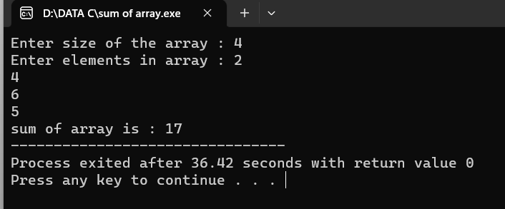

1. write a c program to merge two arrays

Program:

#include<stdio.h>

#include<conio.h>

int main()

{

int arr1[50], arr2[50], size1, size2, i, k, merge[100];

printf("Enter Array 1 Size: ");

scanf("%d", &size1);

printf("Enter Array 1 Elements: ");

for(i=0; i<size1; i++)

{

scanf("%d", &arr1[i]);

merge[i] = arr1[i];

}

k = i;

printf("\nEnter Array 2 Size: ");

scanf("%d", &size2);

printf("Enter Array 2 Elements: ");

for(i=0; i<size2; i++)

{

scanf("%d", &arr2[i]);

merge[k] = arr2[i];

k++;

}

printf("\nThe new array after merging is:\n");

for(i=0; i<k; i++)

printf("%d ", merge[i]);

getch();

return 0;

}

Output:

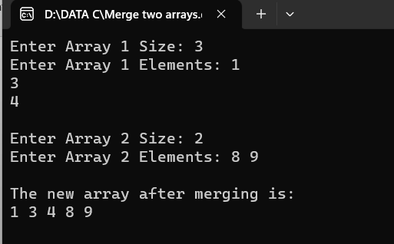

1. write a c program to perform insertion and deletion from the middle in the array.

Program:

#include <stdio.h>

#include <conio.h>

int main ()

{

int arr[50];

int pos, i, num;

printf (" \n Enter the number of elements in an array: \n ");

scanf (" %d", &num);

printf (" \n Enter %d elements in array: \n ", num);

for (i = 0; i < num; i++ )

{ printf (" arr[%d] = ", i);

scanf (" %d", &arr[i]);

}

printf( " Delete the element : \n ");

scanf (" %d", &pos);

if (pos >= num+1)

{

printf (" \n Delete is not possible.");

}

else

{

for (i = pos - 1; i < num -1; i++)

{

arr[i] = arr[i+1];

}

printf (" \n The resultant array is: \n");

for (i = 0; i< num - 1; i++)

{

printf (" arr[%d] = ", i);

printf (" %d \n", arr[i]);

}

}

return 0;

}

Output: 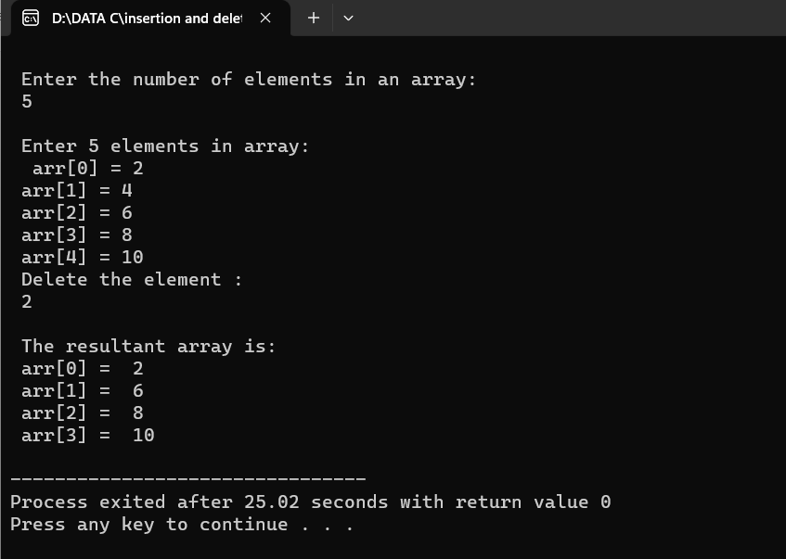

1. write a c program to reverse a string

Program:

#include<stdio.h>

int main()

{

int i,n;

char str[50];

printf("enter a string\n");

gets(str);

n=strlen(str);

printf("\nreverse string\n");

for(i=n-1;i>=0;i--)

{

printf("%c",str[i]);

}

}

Output:

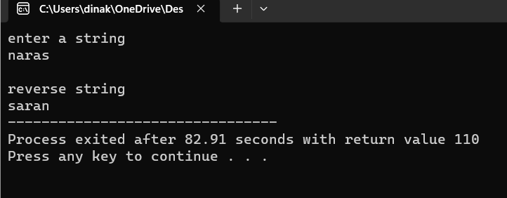

1. write a c program to check given string is pallindrome or not

Program:

#include <stdio.h>

#include <string.h>

int checkpalindrome(char *s)

{

int i,c=0,n;

n=strlen(s);

for(i=0;i<n/2;i++)

{

if(s[i]==s[n-i-1])

c++;}

if(c==i)

return 1;

else

return 0;}

int main()

{char s[1000];

printf("Enter the string: ");

gets(s);

if(checkpalindrome(s))

printf("string is palindrome");

else

printf("string is not palindrome");

}

Output: 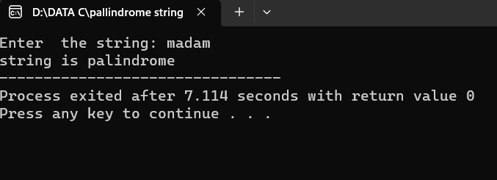

1. write a c program to search particular character in a string(if the character found return to be index)

Program:

#include <stdio.h>

int main()

{

char str[30],ch;

int ind[10],loop,j;

printf("Enter string: ");

scanf("%[^\n]s",str);

printf("Enter character: ");

getchar();

ch=getchar();

j=0;

for(loop=0; str[loop]!='\0'; loop++)

{

if(str[loop]==ch)

ind[j++]=loop;

}

printf("Input string is: %s\n",str);

printf("Indexes: ");

for(loop=0; loop<j; loop++)

printf("%d \t",ind[loop]);

return 0; }

Output: 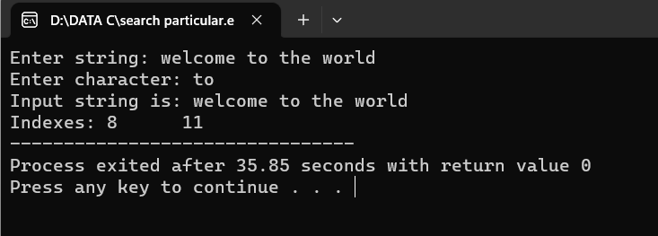

1. write a c program to count no of times present in the given string

Program:

#include <stdio.h>

#include <string.h>

int main()

{ char str[100];

int vowels = 0;

printf("Enter a string: ");

fgets(str, 100, stdin);

for(int i = 0; i < strlen(str); i++)

{

if(str[i] == 'a' || str[i] == 'e' || str[i] == 'i' || str[i] == 'o' || str[i] == 'u' || str[i] == 'A' || str[i] == 'E' || str[i] == 'I' || str[i] == 'O' || str[i] == 'U')

{

vowels++;

}

}

printf("Number of vowels: %d", vowels);

return 0;

}

Output:

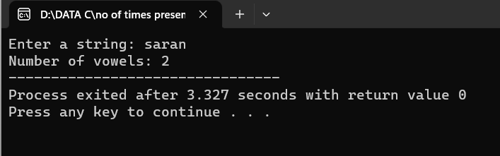

1. write a c program to perfom matrix multiplication

Program:

#include<stdio.h>

#include<stdlib.h>

int main(){

int a[10][10],b[10][10],mul[10][10],r,c,i,j,k;

system("cls");

printf("enter the number of row=");

scanf("%d",&r);

printf("enter the number of column=");

scanf("%d",&c);

printf("enter the first matrix element=\n");

for(i=0;i<r;i++)

{ for(j=0;j<c;j++)

{ scanf("%d",&a[i][j]); }

} printf("enter the second matrix element=\n");

for(i=0;i<r;i++) {

for(j=0;j<c;j++) {

scanf("%d",&b[i][j]);

}

} printf("multiply of the matrix=\n");

for(i=0;i<r;i++) {

for(j=0;j<c;j++) {

mul[i][j]=0;

for(k=0;k<c;k++)

{ mul[i][j]+=a[i][k]*b[k][j];}}}

for(i=0;i<r;i++){

for(j=0;j<c;j++){

printf("%d\t",mul[i][j]);}

printf("\n");}

return 0;

}

Output:

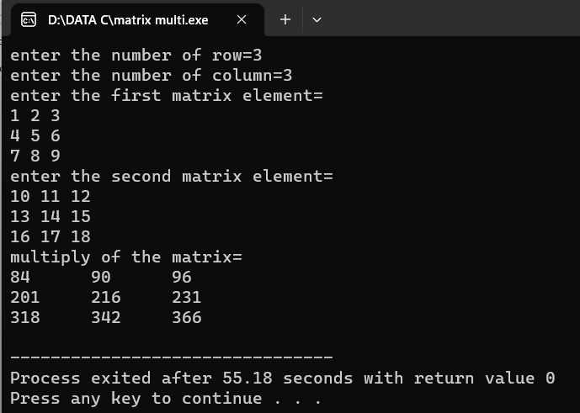

1. write a c program to perform all string manipulation

Program:

#include <stdio.h>

int main(void)

{

char str[] = "SARAN";

int i;

i = 0;

while(str[i] != '\0') {

printf("%c\n", str[i]);

i++;

}

printf("End of code\n");

return 0;

}

Output:

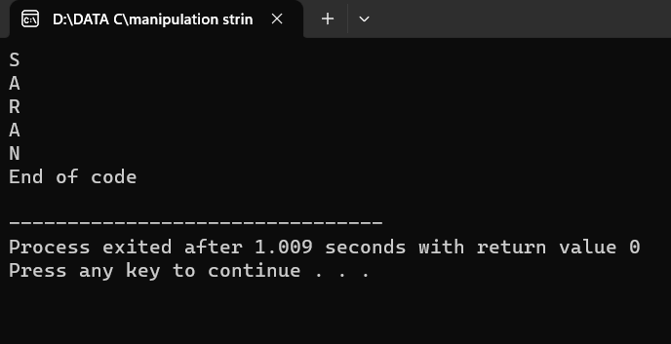

DAY-3

1.write a c program to implement singly linked list with following operation

case-1:

insert an element

Delete element from the list

Finally display the values.

Program:

#include <stdio.h>

#include <stdlib.h>

struct Node {

int data;

struct Node* next;

};

void insert(struct Node** head, int value) {

struct Node* newNode = (struct Node*)malloc(sizeof(struct Node));

newNode->data = value;

newNode->next = NULL;

if (*head == NULL) {

*head = newNode;

} else {

struct Node* current = *head;

while (current->next != NULL) {

current = current->next;

}

current->next = newNode;

}}

void deleteElement(struct Node** head, int value) {

if (*head == NULL) {

printf("List is empty.\n");

return;

}

struct Node* current = *head;

struct Node* previous = NULL;

while (current != NULL && current->data != value) {

previous = current;

current = current->next;

} if (current == NULL) {

printf("Element not found in the list.\n");

return;

} if (previous == NULL) {

*head = current->next;

} else {

previous->next = current->next;

} free(current);

printf("Element deleted successfully.\n");

}

void display(struct Node* head) {

struct Node* current = head;

while (current != NULL) {

printf("%d ", current->data);

current = current->next;

} printf("\n");

}

int main() {

struct Node* head = NULL;

int choice, value;

while (1) {

printf("1. Insert an element\n");

printf("2. Delete an element\n");

printf("3. Display the list\n");

printf("4. Exit\n");

printf("Enter your choice: ");

scanf("%d", &choice);

switch (choice) {

case 1:

printf("Enter the value to insert: ");

scanf("%d", &value);

insert(&head, value);

break;

case 2:

printf("Enter the value to delete: ");

scanf("%d", &value);

deleteElement(&head, value);

break;

case 3:

display(head);

break;

case 4:

exit(0);

default:

printf("Invalid choice. Please try again.\n");}}

return 0; }

Output:

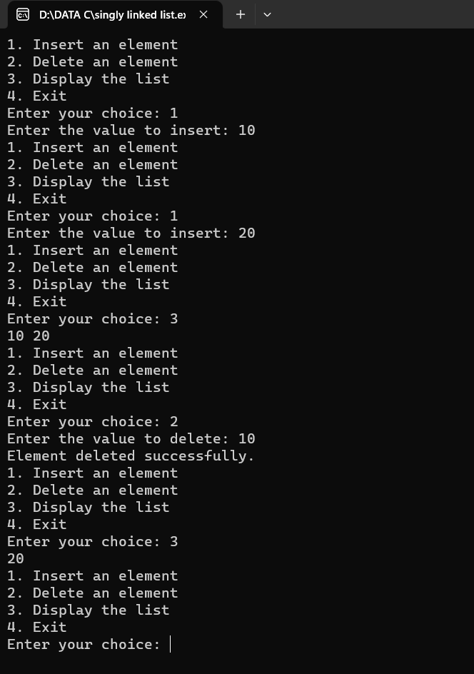

2. .write a c program to implement stack data structures

push an element into the stack,pop and element from the stack,display

element from the stack.

Program:

#include<stdio.h>

#include<stdlib.h>

#define MAXSIZE 5

struct stack

{

int stk[MAXSIZE];

int top;

};

typedef struct stack ST;

ST s;

void push ()

{

int num;

if (s.top == (MAXSIZE - 1))

{

printf ("Stack is Full\n");

return; }

else

{

printf ("\nEnter element to be pushed : ");

scanf ("%d", &num);

s.top = s.top + 1;

s.stk[s.top] = num;

}

return;

}

int pop ()

{

int num;

if (s.top == - 1)

{

printf ("Stack is Empty\n");

return (s.top);

}

else

{

num = s.stk[s.top];

printf ("poped element is = %d\n", s.stk[s.top]);

s.top = s.top - 1;

}

return(num);

}

void display ()

{

int i;

if (s.top == -1)

{

printf ("Stack is empty\n");

return;

}

else

{

printf ("\nStatus of elements in stack : \n");

for (i = s.top; i >= 0; i--)

{

printf ("%d\n", s.stk[i]);

}} }

int main ()

{

int ch;

s.top = -1;

printf ("\tSTACK OPERATIONS\n");

printf("----------------------------\n");

printf(" 1. PUSH\n");

printf(" 2. POP\n");

printf(" 3. DISPLAY\n");

printf(" 4. EXIT\n");

while(1)

{

printf("\nChoose operation : ");

scanf("%d", &ch);

switch (ch) {

case 1:

push();

break;

case 2:

pop();

break;

case 3:

display();

break;

case 4:

exit(0);

default:

printf("Invalid operation \n");}}

return 0; }

Output:

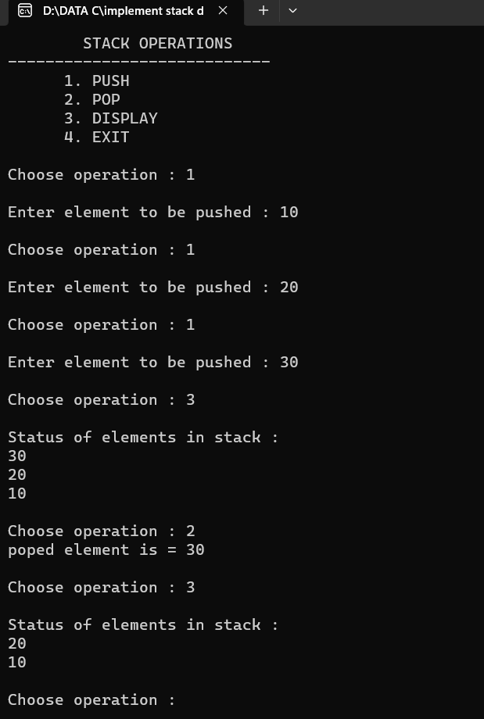

3. write a c program to implement queue as in follow

eneque,dequeue,and display.

Program:

#include<stdio.h>

#define SIZE 3

struct queue

{

int values[SIZE];

int front;

int rear;

};

void enqueue(int);

int dequeue();

int isEmpty();

int isFull();

void display();

struct queue q;

int main()

{

q.front = -1;

q.rear = -1;

int user_choice, data;

char user_active = 'Y';

while (user_active == 'Y' || user_active == 'y')

{ printf("\n--------Queue Program------\n");

printf("\n1. Enqueue");

printf("\n2. Dequeue");

printf("\n3. Display");

printf("\n4. Exit");

printf("\n\nEnter your choice: ");

scanf("%d", &user_choice);

switch(user_choice)

{ case 1:

printf("\nEnter Data: ");

scanf("%d", &data);

enqueue(data);

break;

case 2:

if (!isEmpty())

{

data = dequeue();

printf("\n* %d was removed!\n", data);}

else

{ printf("\nQueue is Empty!\n");}

break;

case 3:

display();

printf("\n");

break;

case 4:

printf("\n\tProgram was terminated!\n\n");

return 1;

default:

printf("\n\tInvalid Choice\n");

} printf("\nDo You want to continue? ");

fflush(stdin);

scanf(" %c", &user_active); }

return 0;

} int isEmpty()

{

if (q.front == -1 || q.front > q.rear)

{ return 1; }

return 0; }

int isFull()

{

if (q.rear == SIZE - 1)

{ return 1; }

return 0; }

void enqueue(int data)

{ if (isFull()) {

printf("\nQueue is Full!\n");

return;

} if (isEmpty())

{ q.front += 1; }

q.rear += 1;

q.values[q.rear] = data;

printf("\n* %d was inserted!\n", data);

} int dequeue()

{ if (!isEmpty())

{ int data = q.values[q.front];

q.front += 1;

return data;}}

void display()

{ if (isEmpty()){

printf("\nQueue is Empty\n");

return;

} printf("\n");

int begin = q.front;

while (begin <= q.rear)

{ printf("%d ", q.values[begin]);

begin += 1; }}

Output:

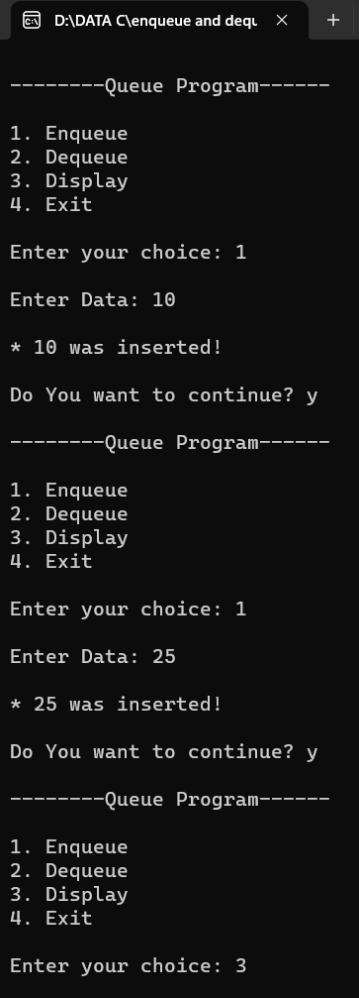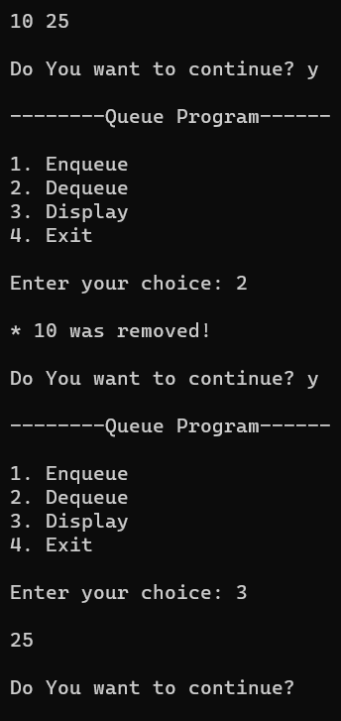

4. write a c program convert infix expression into postfix expression using stack

Program:

#include<stdio.h>

#include<ctype.h>

char stack[100];

int top = -1;

void push(char x)

{ stack[++top] = x; }

char pop()

{ if(top == -1)

return -1;

else

return stack[top--]; }

int priority(char x)

{

if(x == '(')

return 0;

if(x == '+' || x == '-')

return 1;

if(x == '*' || x == '/')

return 2;

return 0;

}

int main()

{

char exp[100];

char *e, x;

printf("Enter the expression : ");

scanf("%s",exp);

printf("\n");

e = exp;

while(*e != '\0')

{ if(isalnum(*e))

printf("%c ",*e);

else if(*e == '(')

push(*e);

else if(*e == ')')

{ while((x = pop()) != '(')

printf("%c ", x);}

else

{ while(priority(stack[top]) >= priority(*e))

printf("%c ",pop());

push(*e);

} e++;

} while(top != -1)

{

printf("%c ",pop());

} return 0;

}

Output:

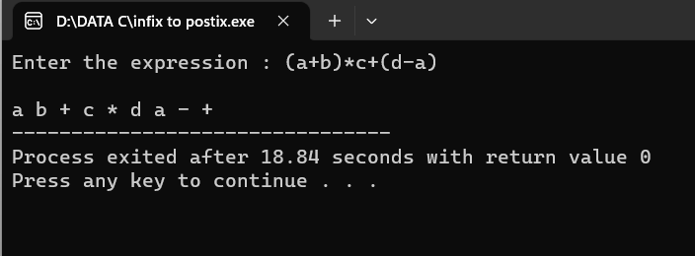

5.Write a c program evaluate the given expression using stack

Program:

#include <stdio.h>

#include <ctype.h>

#define MAXSTACK 100

#define POSTFIXSIZE 100

int stack[MAXSTACK];

int top = -1;

void push(int item)

{ if (top >= MAXSTACK - 1) {

printf("stack over flow");

return;

}

else {

top = top + 1;

stack[top] = item;

} }

int pop()

{

int item;

if (top < 0) {

printf("stack under flow");

}

else {

item = stack[top];

top = top - 1;

return item;

} } void EvalPostfix(char postfix[])

{ int i;

char ch;

int val;

int A, B;

for (i = 0; postfix[i] != ')'; i++) {

ch = postfix[i];

if (isdigit(ch)) {

push(ch - '0');

}

else if (ch == '+' || ch == '-' || ch == '*' || ch == '/') {

A = pop();

B = pop();

switch (ch)

{

case '*':

val = B * A;

break;

case '/':

val = B / A;

break;

case '+':

val = B + A;

break;

case '-':

val = B - A;

break; }

push(val); } }

printf(" \n Result of expression evaluation : %d \n", pop());

}

int main()

{ int i;

char postfix[POSTFIXSIZE];

printf(" There are only four operators(*, /, +, -) in an expression and operand is single digit only.\n");

printf(" \nEnter postfix expression,\npress right parenthesis ')' for end expression : ");

for (i = 0; i <= POSTFIXSIZE - 1; i++) {

scanf("%c", &postfix[i]);

if (postfix[i] == ')')

{

break;

}

} EvalPostfix(postfix);

return 0;

}

Output:

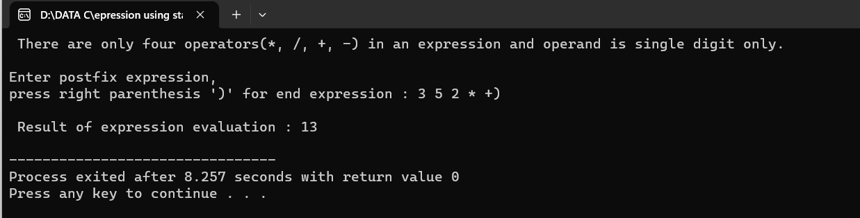

DAY-4

1. write a c program to binary tree traversal a tree.

Program:

#include <stdio.h>

#include <stdlib.h>

struct tnode {

int data;

struct tnode *left, *right;

};

struct tnode *root = NULL;

struct tnode * createNode(int data) {

struct tnode *newNode;

newNode = (struct tnode *) malloc(sizeof(struct tnode));

newNode->data = data;

newNode->left = NULL;

newNode->right = NULL;

return (newNode); }

void insertion(struct tnode **node, int data) {

if (!*node) {

*node = createNode(data);

} else if (data < (*node)->data) {

insertion(&(*node)->left, data);

} else if (data > (*node)->data) {

insertion(&(*node)->right, data); } }

void postOrder(struct tnode *node) {

if (node) {

postOrder(node->left);

postOrder(node->right);

printf("%d ", node->data); }

return; }

void preOrder(struct tnode *node) {

if (node) {

printf("%d ", node->data);

preOrder(node->left);

preOrder(node->right); }

return; }

void inOrder(struct tnode *node) {

if (node) {

inOrder(node->left);

printf("%d ", node->data);

inOrder(node->right); }

return; }

int main() {

int data, ch;

while (1) {

printf("\n1. Insertion\n2. Pre-order\n");

printf("3. Post-order\n4. In-order\n");

printf("5. Exit\nEnter your choice:");

scanf("%d", &ch);

switch (ch) {

case 1:

printf("Enter ur data:");

scanf("%d", &data);

insertion(&root, data);

break;

case 2:

preOrder(root);

break;

case 3:

postOrder(root);

break;

case 4:

inOrder(root);

break;

case 5:

exit(0);

default:

printf("U've entered wrong opetion\n");

break; } }

return 0; }

Output:

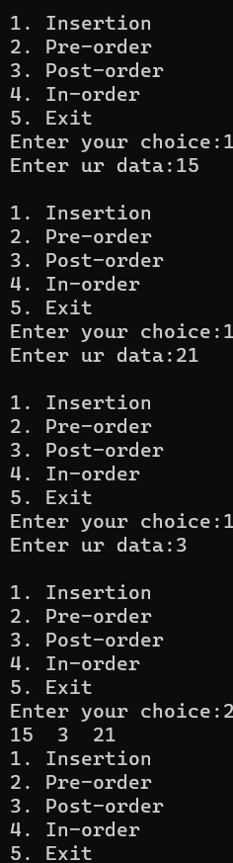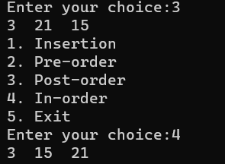

1. write a c program to insert the implement AVL tree in all rotations

Program:

#include <stdio.h>

#include <stdlib.h>

struct Node

{

int key;

struct Node *left;

struct Node *right;

int height;

};

int getHeight(struct Node *n){

if(n==NULL)

return 0;

return n->height;

} struct Node *createNode(int key){

struct Node* node = (struct Node *) malloc(sizeof(struct Node));

node->key = key;

node->left = NULL;

node->right = NULL;

node->height = 1;

return node;

} int max (int a, int b){

return (a>b)?a:b;

}

int getBalanceFactor(struct Node * n){

if(n==NULL){

return 0;

}

return getHeight(n->left) - getHeight(n->right);

}

struct Node* rightRotate(struct Node* y){

struct Node* x = y->left;

struct Node* T2 = x->right;

x->right = y;

y->left = T2;

x->height = max(getHeight(x->right), getHeight(x->left)) + 1;

y->height = max(getHeight(y->right), getHeight(y->left)) + 1;

return x;

}

struct Node* leftRotate(struct Node* x){

struct Node* y = x->right;

struct Node* T2 = y->left;

y->left = x;

x->right = T2;

x->height = max(getHeight(x->right), getHeight(x->left)) + 1;

y->height = max(getHeight(y->right), getHeight(y->left)) + 1;

return y;

} struct Node *insert(struct Node* node, int key){

if (node == NULL)

return createNode(key);

if (key < node->key)

node->left = insert(node->left, key);

else if (key > node->key)

node->right = insert(node->right, key);

node->height = 1 + max(getHeight(node->left), getHeight(node->right));

int bf = getBalanceFactor(node);

if(bf>1 && key < node->left->key){

return rightRotate(node);

}

if(bf<-1 && key > node->right->key){

return leftRotate(node);

}

if(bf>1 && key > node->left->key){

node->left = leftRotate(node->left);

return rightRotate(node);

}

if(bf<-1 && key < node->right->key){

node->right = rightRotate(node->right);

return leftRotate(node);

}

return node;

}

void preOrder(struct Node *root)

{

if(root != NULL)

{

printf("%d ", root->key);

preOrder(root->left);

preOrder(root->right);

}

}

int main(){

struct Node * root = NULL;

root = insert(root, 1);

root = insert(root, 2);

root = insert(root, 4);

root = insert(root, 5);

root = insert(root, 6);

root = insert(root, 3);

preOrder(root);

return 0;

}

Output:

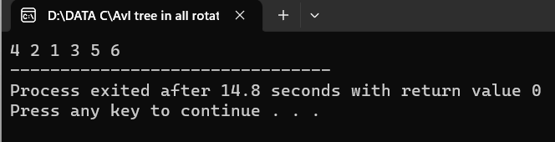

1. write a c program to implement hashing using linear probing

Program:

#include <stdio.h>

#include<stdlib.h>

#define TABLE_SIZE 10

int h[TABLE_SIZE]={NULL};

void insert()

{

int key,index,i,flag=0,hkey;

printf("\nenter a value to insert into hash table\n");

scanf("%d",&key);

hkey=key%TABLE_SIZE;

for(i=0;i<TABLE_SIZE;i++)

{

index=(hkey+i)%TABLE_SIZE;

if(h[index] == NULL)

{

h[index]=key;

break; } }

if(i == TABLE_SIZE)

printf("\nelement cannot be inserted\n");

}

void search()

{ int key,index,i,flag=0,hkey;

printf("\nenter search element\n");

scanf("%d",&key);

hkey=key%TABLE_SIZE;

for(i=0;i<TABLE_SIZE; i++)

{ index=(hkey+i)%TABLE_SIZE;

if(h[index]==key)

{

printf("value is found at index %d",index);

break;

}

}

if(i == TABLE_SIZE)

printf("\n value is not found\n");

}

void display()

{ int i;

printf("\nelements in the hash table are \n");

for(i=0;i< TABLE_SIZE; i++)

printf("\nat index %d \t value = %d",i,h[i]);

}

main()

{ int opt,i;

while(1)

{

printf("\nPress 1. Insert\t 2. Display \t3. Search \t4.Exit \n");

scanf("%d",&opt);

switch(opt)

{

case 1:

insert();

break;

case 2:

display();

break;

case 3:

search();

break;

case 4:exit(0); } } }

Output:

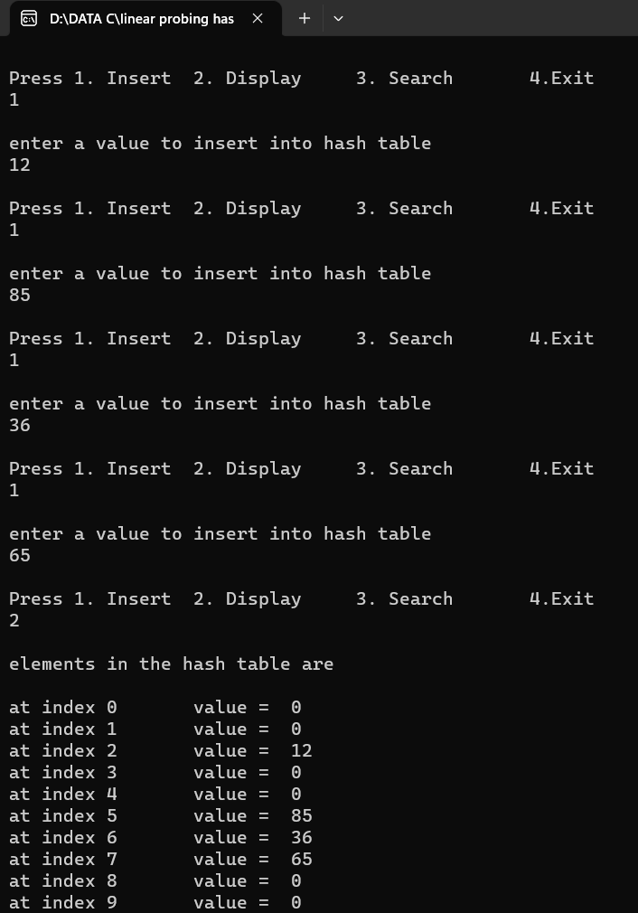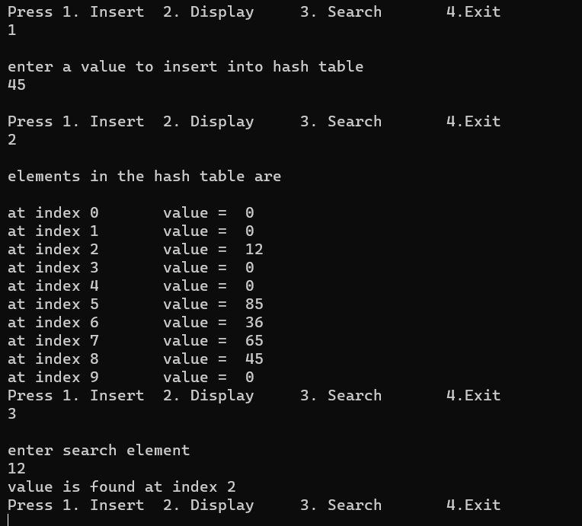

4.

a. write a c program to implement selection sort

Program:

#include <stdio.h>

void selection(int arr[], int n)

{ int i, j, small;

for (i = 0; i < n-1; i++)

{ small = i;

for (j = i+1; j < n; j++)

if (arr[j] < arr[small])

small = j;

int temp = arr[small];

arr[small] = arr[i];

arr[i] = temp;

}

} void printArr(int a[], int n)

{ int i;

for (i = 0; i < n; i++)

printf("%d ", a[i]);

} int main()

{

int a[] = { 12, 31, 25, 8, 32, 17 };

int n = sizeof(a) / sizeof(a[0]);

printf("Before sorting array elements are - \n");

printArr(a, n);

selection(a, n);

printf("\nAfter sorting array elements are - \n");

printArr(a, n);

return 0;

}

Output:

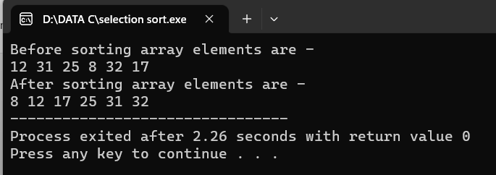

b. write a c program to implement insertion sort

Program:

#include <stdio.h>

void insert(int a[], int n)

{ int i, j, temp;

for (i = 1; i < n; i++) {

temp = a[i];

j = i - 1;

while(j>=0 && temp <= a[j])

{

a[j+1] = a[j];

j = j-1;

}

a[j+1] = temp;

}

} void printArr(int a[], int n)

{

int i;

for (i = 0; i < n; i++)

printf("%d ", a[i]);

}

int main()

{

int a[] = { 21, 71, 28, 8, 2, 19 };

int n = sizeof(a) / sizeof(a[0]);

printf("Before sorting array elements are - \n");

printArr(a, n);

insert(a, n);

printf("\nAfter sorting array elements are - \n");

printArr(a, n);

return 0;

}

Output:

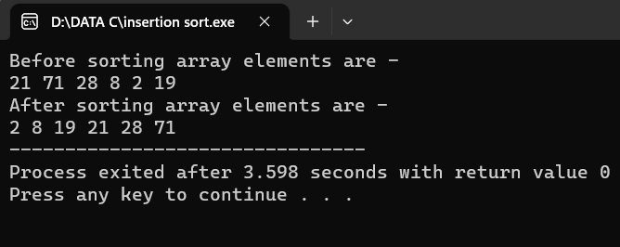

c. write a c program to implement quick sort

Program:

#include <stdio.h>

void swap(int* a, int* b) {

int t = *a;

*a = *b;

*b = t;

}

int partition(int arr[], int low, int high) {

int pivot = arr[high];

int i = (low - 1);

for (int j = low; j <= high - 1; j++) {

if (arr[j] < pivot) {

i++;

swap(&arr[i], &arr[j]);

}

}

swap(&arr[i + 1], &arr[high]);

return (i + 1);

}

void quickSort(int arr[], int low, int high) {

if (low < high) {

int pi = partition(arr, low, high);

quickSort(arr, low, pi - 1);

quickSort(arr, pi + 1, high);

}

}

void printArray(int arr[], int size) {

int i;

for (i = 0; i < size; i++)

printf("%d ", arr[i]);

printf("\n");

}

int main() {

int arr[] = { 12, 17, 6, 25, 1, 5 };

int n = sizeof(arr) / sizeof(arr[0]);

quickSort(arr, 0, n - 1);

printf("Sorted array: \n");

printArray(arr, n);

return 0;

}

Output:

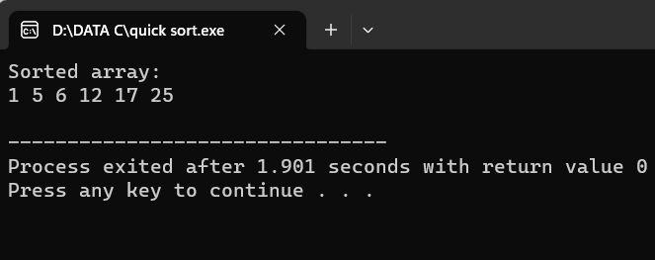

d. write a c program to implement Bubble sort

Program:

#include <stdio.h>

void bubble_sort(int arr[], int n) {

int i, j;

for (i = 0; i < n - 1; i++) {

for (j = 0; j < n - i - 1; j++) {

if (arr[j] > arr[j + 1]) {

int temp = arr[j];

arr[j] = arr[j + 1];

arr[j + 1] = temp;

}

}

}

}

int main() {

int arr[] = {64, 34, 25, 12, 22, 11, 90};

int n = sizeof(arr) / sizeof(arr[0]);

bubble_sort(arr, n);

printf("Sorted array: ");

for (int i = 0; i < n; i++) {

printf("%d ", arr[i]);

}

return 0;

}

Output:

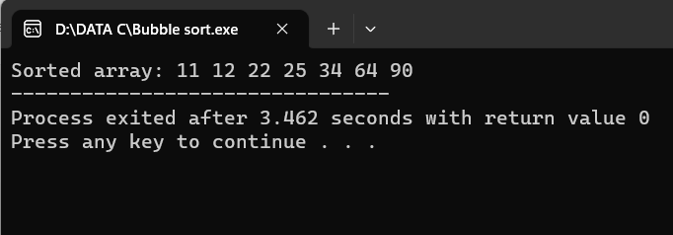

DAY-5

1.Write a c program to implement single shortest distance.

Program:

#include<stdio.h>

#include<conio.h>

#define INFINITY 9999

#define MAX 10

void dijkstra(int G[MAX][MAX],int n,int startnode);

int main()

{

int G[MAX][MAX],i,j,n,u;

printf("Enter no. of vertices:");

scanf("%d",&n);

printf("\nEnter the adjacency matrix:\n");

for(i=0;i<n;i++)

for(j=0;j<n;j++)

scanf("%d",&G[i][j]);

printf("\nEnter the starting node:");

scanf("%d",&u);

dijkstra(G,n,u);

return 0;

}

void dijkstra(int G[MAX][MAX],int n,int startnode)

{

int cost[MAX][MAX],distance[MAX],pred[MAX];

int visited[MAX],count,mindistance,nextnode,i,j;

for(i=0;i<n;i++)

for(j=0;j<n;j++)

if(G[i][j]==0)

cost[i][j]=INFINITY;

else

cost[i][j]=G[i][j];

for(i=0;i<n;i++)

{

distance[i]=cost[startnode][i];

pred[i]=startnode;

visited[i]=0;

}

distance[startnode]=0;

visited[startnode]=1;

count=1;

while(count<n-1)

{

mindistance=INFINITY;

for(i=0;i<n;i++)

if(distance[i]<mindistance&&!visited[i])

{

mindistance=distance[i];

nextnode=i;

}

visited[nextnode]=1;

for(i=0;i<n;i++)

if(!visited[i])

if(mindistance+cost[nextnode][i]<distance[i])

{

distance[i]=mindistance+cost[nextnode][i];

pred[i]=nextnode;

}

count++;

}

for(i=0;i<n;i++)

if(i!=startnode)

{

printf("\nDistance of node%d=%d",i,distance[i]);

printf("\nPath=%d",i);

j=i;

do

{

j=pred[j];

printf("<-%d",j);

}while(j!=startnode);

}

}

Output:

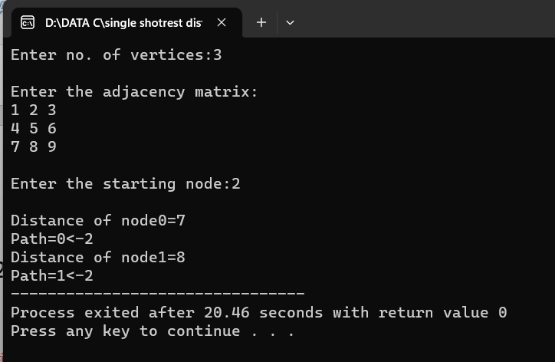

2.write a c program minimum spamming tree using prims method

Program:

#include <stdio.h>

#include <limits.h>

#define V 5

int minKey(int key[], int mstSet[]) {

int min = INT_MAX, min_index;

int v;

for (v = 0; v < V; v++)

if (mstSet[v] == 0 && key[v] < min)

min = key[v], min_index = v;

return min_index;

}

int printMST(int parent[], int n, int graph[V][V]) {

int i;

printf("Edge Weight\n");

for (i = 1; i < V; i++)

printf("%d - %d %d \n", parent[i], i, graph[i][parent[i]]);

} void primMST(int graph[V][V]) {

int parent[V];

int key[V], i, v, count;

int mstSet[V];

for (i = 0; i < V; i++)

key[i] = INT_MAX, mstSet[i] = 0;

key[0] = 0;

parent[0] = -1;

for (count = 0; count < V - 1; count++) {

int u = minKey(key, mstSet);

mstSet[u] = 1;

for (v = 0; v < V; v++)

if (graph[u][v] && mstSet[v] == 0 && graph[u][v] < key[v])

parent[v] = u, key[v] = graph[u][v];

} printMST(parent, V, graph);

} int main() {

int graph[V][V] = { { 0, 2, 0, 6, 0 }, { 2, 0, 3, 8, 5 },

{ 0, 3, 0, 0, 7 }, { 6, 8, 0, 0, 9 }, { 0, 5, 7, 9, 0 }, };

primMST(graph);

return 0;

}

Output:

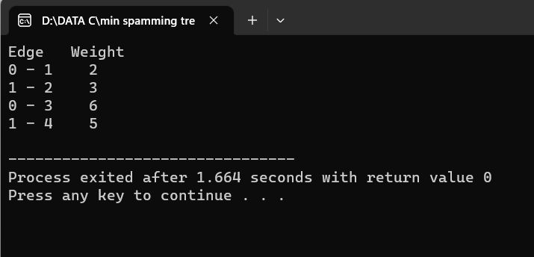

3.write a c program minimum spamming tree using Kruskal method

Program:

#include <stdio.h>

#define MAX 30

typedef struct edge {

int u, v, w;

} edge;

typedef struct edge_list {

edge data[MAX];

int n;

} edge_list;

edge_list elist;

int Graph[MAX][MAX], n;

edge_list spanlist;

void kruskalAlgo();

int find(int belongs[], int vertexno);

void applyUnion(int belongs[], int c1, int c2);

void sort();

void print();

void kruskalAlgo() {

int belongs[MAX], i, j, cno1, cno2;

elist.n = 0;

for (i = 1; i < n; i++)

for (j = 0; j < i; j++) {

if (Graph[i][j] != 0) {

elist.data[elist.n].u = i;

elist.data[elist.n].v = j;

elist.data[elist.n].w = Graph[i][j];

elist.n++;

}

}

sort();

for (i = 0; i < n; i++)

belongs[i] = i;

spanlist.n = 0;

for (i = 0; i < elist.n; i++) {

cno1 = find(belongs, elist.data[i].u);

cno2 = find(belongs, elist.data[i].v);

if (cno1 != cno2) {

spanlist.data[spanlist.n] = elist.data[i];

spanlist.n = spanlist.n + 1;

applyUnion(belongs, cno1, cno2);

}

}

}

int find(int belongs[], int vertexno) {

return (belongs[vertexno]);

}

void applyUnion(int belongs[], int c1, int c2) {

int i;

for (i = 0; i < n; i++)

if (belongs[i] == c2)

belongs[i] = c1;

}

void sort() {

int i, j;

edge temp;

for (i = 1; i < elist.n; i++)

for (j = 0; j < elist.n - 1; j++)

if (elist.data[j].w > elist.data[j + 1].w) {

temp = elist.data[j];

elist.data[j] = elist.data[j + 1];

elist.data[j + 1] = temp;

}

}

void print() {

int i, cost = 0;

for (i = 0; i < spanlist.n; i++) {

printf("\n%d - %d : %d", spanlist.data[i].u, spanlist.data[i].v, spanlist.data[i].w);

cost = cost + spanlist.data[i].w;

}

printf("\nSpanning tree cost: %d", cost);

}

int main() {

int i, j, total_cost;

n = 6;

Graph[0][0] = 0;

Graph[0][1] = 4;

Graph[0][2] = 4;

Graph[0][3] = 0;

Graph[0][4] = 0;

Graph[0][5] = 0;

Graph[0][6] = 0;

Graph[1][0] = 4;

Graph[1][1] = 0;

Graph[1][2] = 2;

Graph[1][3] = 0;

Graph[1][4] = 0;

Graph[1][5] = 0;

Graph[1][6] = 0;

Graph[2][0] = 4;

Graph[2][1] = 2;

Graph[2][2] = 0;

Graph[2][3] = 3;

Graph[2][4] = 4;

Graph[2][5] = 0;

Graph[2][6] = 0;

Graph[3][0] = 0;

Graph[3][1] = 0;

Graph[3][2] = 3;

Graph[3][3] = 0;

Graph[3][4] = 3;

Graph[3][5] = 0;

Graph[3][6] = 0;

Graph[4][0] = 0;

Graph[4][1] = 0;

Graph[4][2] = 4;

Graph[4][3] = 3;

Graph[4][4] = 0;

Graph[4][5] = 0;

Graph[4][6] = 0;

Graph[5][0] = 0;

Graph[5][1] = 0;

Graph[5][2] = 2;

Graph[5][3] = 0;

Graph[5][4] = 3;

Graph[5][5] = 0;

Graph[5][6] = 0;

kruskalAlgo();

print();

}

Output:

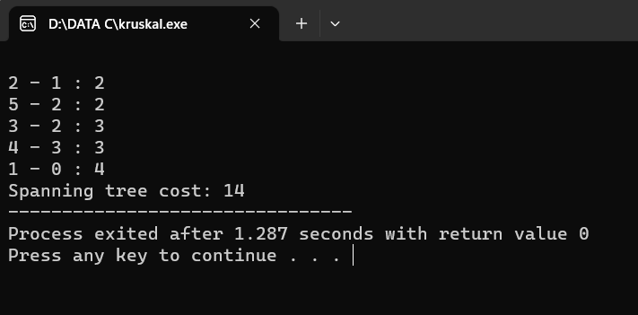

4.write a c program to implement depth first search graph traversal

Program:

#include <stdio.h>

#include <stdlib.h>

int vis[100];

struct Graph {

int V;

int E;

int** Adj;

};

struct Graph* adjMatrix()

{ struct Graph* G = (struct Graph*)

malloc(sizeof(struct Graph));

if (!G) {

printf("Memory Error\n");

return NULL;

} G->V = 7;

G->E = 7;

G->Adj = (int**)malloc((G->V) * sizeof(int*));

for (int k = 0; k < G->V; k++) {

G->Adj[k] = (int*)malloc((G->V) * sizeof(int));

}

for (int u = 0; u < G->V; u++) {

for (int v = 0; v < G->V; v++) {

G->Adj[u][v] = 0;

} }

G->Adj[0][1] = G->Adj[1][0] = 1;

G->Adj[0][2] = G->Adj[2][0] = 1;

G->Adj[1][3] = G->Adj[3][1] = 1;

G->Adj[1][4] = G->Adj[4][1] = 1;

G->Adj[1][5] = G->Adj[5][1] = 1;

G->Adj[1][6] = G->Adj[6][1] = 1;

G->Adj[6][2] = G->Adj[2][6] = 1;

return G;

}

void DFS(struct Graph* G, int u)

{ vis[u] = 1;

printf("%d ", u);

for (int v = 0; v < G->V; v++) {

if (!vis[v] && G->Adj[u][v]) {

DFS(G, v);

}

}

} void DFStraversal(struct Graph* G)

{ for (int i = 0; i < 100; i++) {

vis[i] = 0;

}

for (int i = 0; i < G->V; i++) {

if (!vis[i]) {

DFS(G, i);

}

}

}

int main()

{

struct Graph* G;

G = adjMatrix();

DFStraversal(G);

}

Output:

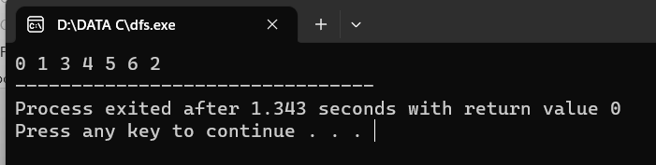

5.Write a c program to implement breadth first graph traversal

Program:

#include <stdio.h>

int n, i, j, visited[10], queue[10], front = -1, rear = -1;

int adj[10][10];

void bfs(int v)

{

for (i = 1; i <= n; i++)

if (adj[v][i] && !visited[i])

queue[++rear] = i;

if (front <= rear)

{

visited[queue[front]] = 1;

bfs(queue[front++]);

}

}

int main()

{

int v;

printf("Enter the number of vertices: ");

scanf("%d", &n);

for (i = 1; i <= n; i++)

{

queue[i] = 0;

visited[i] = 0;

}

printf("Enter graph data in matrix form: \n");

for (i = 1; i <= n; i++)

for (j = 1; j <= n; j++)

scanf("%d", &adj[i][j]);

printf("Enter the starting vertex: ");

scanf("%d", &v);

bfs(v);

printf("The node which are reachable are: \n");

for (i = 1; i <= n; i++)

if (visited[i])

printf("%d\t", i);

else

printf("BFS is not possible. Not all nodes are reachable");

return 0;

}

Output:

